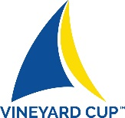

2018 VINEYARD CUP REGATTA

HOSTED BY MARTHA’S VINEYARD SHIPYARD



To Benefit Sail Martha’s Vineyard

13-15 JULY 2018

A LOCALLY Sourced / ZERO Waste Event



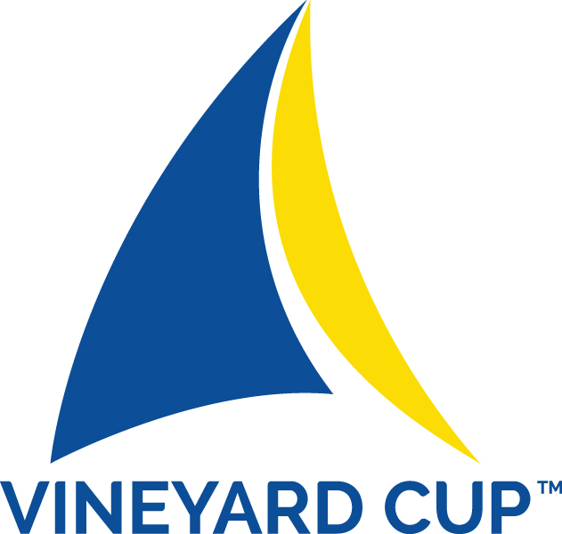

Sail Martha’s Vineyard’s Vineyard Cup Regatta Hosted by the Martha’s Vineyard Shipyard

Kicks off SIX DAYS OF RACING OVER A NINE DAY PERIOD and is held on the waters of Nantucket Sound and Vineyard Sound off of the Island of Martha’s Vineyard on Friday, Saturday and Sunday, July 13th, 14th, 15th, 2018. Sail Martha’s Vineyard (“SMV”) is the Organizing Authority www.sailmv.com and invites vessels of at least 18 feet in length to come and enjoy a great blend of sailing, fun and island food and drink. All proceeds of the event help to support the year round maritime programs of Sail Martha’s Vineyard.

…and while you’re in the area

Our friends at Edgartown Yacht Club will be hosting their Big Boat Buoy Races and 'Round The Island Race July 19th - 21st. Added to their schedule this year will be a race for vessels not meeting the ISAF Special Regulations for offshore and ocean racing Category 4 requirements on Saturday, July 21st.
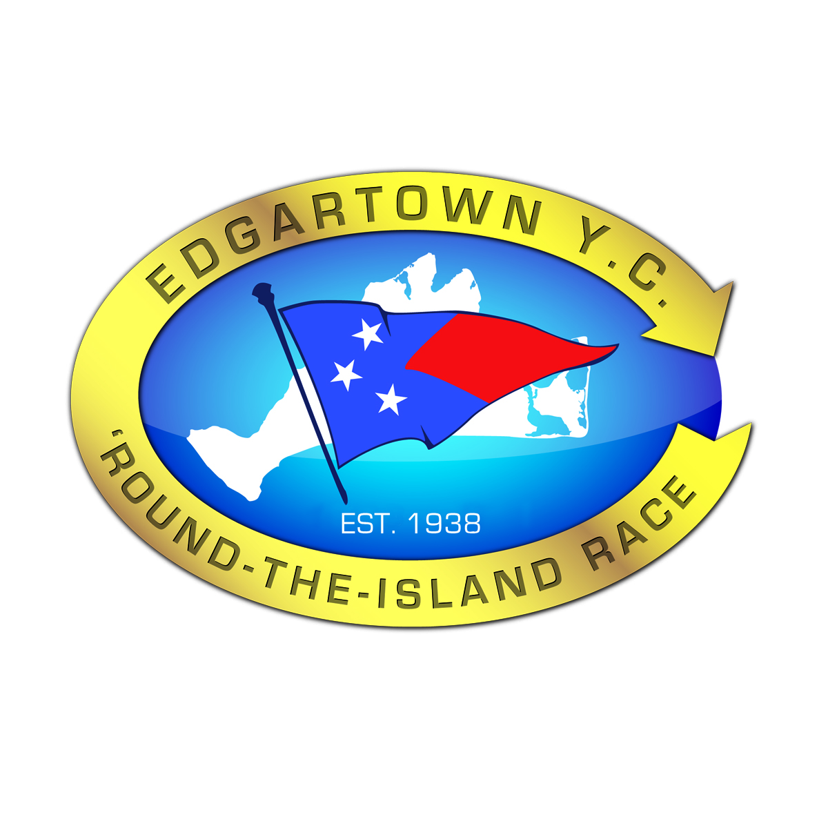
www.rtirace.org

The time between the Vineyard Cup Regatta and Edgartown's Big Boat and 'RTI Races provides an excellent opportunity for those who enjoy cruising the waters of the Nantucket and Vineyard Sounds and Buzzards Bay."

NOTICE OF RACE

- RULES
  - The regatta will be governed by the rules as defined in The Racing Rules of Sailing 2017-2020 (“RRS”), the prescriptions of US SAILING, any modifications or stated exceptions thereto, class rules for any one-design class competing, the Notice of Expectations and these Sailing Instructions.

- OTHER RULES and REQUIREMENTS
  - All boats must be sailed by a minimum of two sailors.
  - There are no weight limitations (unless otherwise prescribed by the class rules for any one-design class competing).

- ADVERTISING
  - The Cup will be sailed in accordance with ISAF Regulation 20.3.1(b)
  - Vessels may be asked to display a sponsor’s flag provided by the Organizing Authority as permitted by ISAF regulation 20.3 (d)(i)

- ELIGIBILITY
  - The regatta is open to Catboats at least 18 feet LOA and other boats at least 22 feet LOA which either (i) carry a PHRF rating, (ii) fall within the categories of Classic boats, as defined, and carry a CRF rating or (iii) are a one-design class.
  - If entries in any Division warrant, a Division will be divided into Classes to be established at the sole discretion of the Organizing Authority and designated based on one-design class, rating and/or hull material or configuration or any combination thereof.

Eligible boats may enter by completing the online registration form and paying the entry fee online. All boats except the Catboat Divisions must submit a 2018 rating certificate for the Division in which they are registered. Entries and payment may also be sent to Vineyard Cup Entries, c/o Sail Martha’s Vineyard, P.O. Box 1998, Vineyard Haven, Massachusetts 02568.
  - Entries must be received by 1800 hrs July 12, 2018.
NOTE: Sail Martha’s Vineyard may in its sole discretion accept any late entry at any time. A $100 late entry fee will apply.

A 2018 PHRF certificate can be applied for through the Sail Martha’s Vineyard Fleet. (Application available at www.phrfne.org.) You can fill out, pay and submit on the PHRF-NE website.

- CLASSIFICATION
  - The Classic Division is for sailing yachts that have a full keel, are of heavy to moderate displacement, are built of wood or steel and be of traditional rig and appearance.
a. Old craft using modern materials such as epoxy or glass sheathing, or new craft built along the lines of an old design are acceptable.
b. Fiber glass yachts should have a full long keel with a keel hung rudder, and be a descendant of a wooden boat design.
c. Yachts built of other materials may be accepted at the discretion of the Organizing Authority, if they have a gaff or traditional schooner rig.
  - The PHRF Non-Spinnaker Division: A 2018 PHRF-NE Certificate MUST be presented. THERE WILL BE NO EXCEPTIONS.
  - The PHRF Spinnaker Division: A 2018 PHRF-NE Certificate MUST be presented. THERE WILL BE NO EXCEPTIONS.
  - Catboats of at least 18 feet are eligible for the Catboat Division
  - Any one design class that has at least six boats registered may petition the Organizing Authority to designate it as a separate class. Such class, if constituted, will start with its appropriate Division/Class.

- ENTRY FEES
  - Members of Sail Martha’s Vineyard Receive a $25 Discount. JOIN NOW (Click Here)

a. Catboats $75 if entered and paid before June 1, 2018
b. Catboats $125 if entered and paid after May 31, 2018
c. Classics Designed After 1945 $125 if entered and paid before June 1, 2018
d. Classics Designed After 1945 $225 if entered and paid after May 31, 2018
e. Classics Designed Before 1945 $100 if entered and paid before June 1, 2018
f. Classics Designed Before 1945 $200 if entered and paid after May 31, 2018
g. PHRF with LOA >/ 30’ $175 if entered and paid before June 1, 2018
h. PHRF with LOA >/ 30’ $250 if entered and paid after May 31, 2018
i. PHRF with LOA < 30’ $125 if entered and paid before June 1, 2018
j. PHRF with LOA < 30’ $225 if entered and paid after May 31, 2018
  - An owner or skipper who purchases a table at the 2018 Vineyard Cup Opening Gala on the evening of July 12th will not be required to pay an entry fee for his/her vessel.
RESERVE YOUR TABLE (Click Here)

- RACE VILLAGE BRACELETS (Entitles wearer to food and beverage at no additional cost)

i. Adult Weekend (all three days) $90 if purchased before June 1, 2018
ii. Adult Weekend (all three days) $100 if purchased after June 1, 2018
iii. Adult Daily $35 if purchased before May 31, 2018
iv. Adult Daily $45 if purchased after May 31, 2018
v. Under 21 Weekend (all three days) $55 if purchased before June 1, 2018
vi. Under 21 Weekend (all three days) $65 if purchased after June 1, 2018
vii. Under 21 Daily $15 if purchased before May 31, 2018
viii Under 21 Daily $25 if purchased after May 31, 2018

- PRELIMINARY RACING SCHEDULE

  - Friday, Saturday and Sunday, July 13, 14 and 15, 2018

The PHRF Spinnaker and PHRF Non-Spinnaker Divisions

FRIDAY, JULY 13, 2018
First Warning Signal 1300 hrs Division/Class Flag
Preparatory Signal 1306 hrs Code Flag “P”
Start 1310 hrs Div/Class Flag Down

SATURDAY, JULY 14, 2018
First Warning Signal 1010 hrs Division/Class Flag
Preparatory Signal 1016 hrs Code Flag “P”
Start 1020 hrs Div/Class Flag Down

SUNDAY, JULY 15, 2018
Pursuit Race First Boat Warning Signal 1030 hrs Yellow Flag
Preparatory Signal 1036 hrs Blue Flag
Pursuit Starting Sequence Begins 1040 hrs Red Flag

The Classic Division

SATURDAY, JULY 14, 2018
First Warning Signal 1000 hrs Division/Class Flag
Preparatory Signal 1006 hrs Code Flag “P”
Start 1010 hrs Div/Class Flag Down

SUNDAY, JULY 15, 2018
Pursuit Race First Boat Warning Signal 1030 hrs Yellow Flag
Preparatory Signal 1036 hrs Blue Flag
Pursuit Starting Sequence Begins 1040 hrs Red Flag

The Catboat Division

SATURDAY, JULY 14, 2018
First Warning Signal 1200 hrs Division/Class Flag
Preparatory Signal 1206 hrs Code Flag “P”
Start 1210 hrs Div/ Class Flag Down

- SAILING INSTRUCTIONS
  - Sailing Instructions for the PHRF, IRC, Classic and Catboat Divisions will be posted on the Vineyard Cup website, www.vineyardcup.com beginning at 0900 hrs. July 12, 2018. There will be no paper copies made available by Sail Martha’s Vineyard.

- RACE HEADQUARTERS
  - Race Headquarters will be located at the Sail Martha’s Vineyard’s offices which are located at 79 Beach Road in Vineyard Haven.

- RACE COURSES

COURSE #1 THE DASH
(approximately 5.2 nm)
Start, then through the N”4” - C” 23A” gate to G ”23” (leave to port) to RG N (leave to port) through N’4” - C “23A” gate to Finish.

COURSE # 2 THE DASH PLUS
(approximately 7.6 nm)
Start, then through the N”4” - C” 23A” gate to G ”23” (leave to port) to C “15” (leave to port) through the N’4” - C “23A” gate to Finish.

COURSE #3 HEDGE FENCE COURSE
(approximately 9.9 nm)
Start, then through the N”4” - C” 23A” gate to G “23” (leave to starboard) to R “22” (leave to starboard) to GR Bell (leave to starboard) to G “23” (leave to port) through the N”4” - C” 23A” gate to Finish.

COURSE #4 L’HOMMEDIEU SHOAL COURSE
(approximately 10.8 nm)
Start, then through the N”4” - C” 23A” gate to C”25” (leave to port) to R”26” (leave to starboard) to C”15” at the western end of L’Hommedieu Shoal (leave to starboard) to RG N at the west end of Hedge Fence (leave to starboard) through the N”4” – C “23A” gate to Finish.

COURSE # 5 NORTH CHANNEL COURSE
(approximately 10.9 nm)
Start, then through the N “4” – G”23A gate to N “14” (leave to starboard) to G “23” (leave to starboard) to R “2” (leave to port) through the N “4” – C”23A” gate to Finish.

COURSE # 6 VINEYARD SOUND COURSE SHORT
(approximately 12.1 nm)
Start, then through the N “4” – C”23A gate to C ”25” (leave to port) to R ”26” (leave to port) to G ”27” (leave to port) to C ”25” (leave to starboard) through the N “4” – C”23A gate to Finish.

COURSE #7 AROUND HEDGE FENCE COURSE
(approximately 15.4 nm)
Start, then through the N “4” – C”23A gate to RG N (leave to starboard) to C “11” (leave to starboard to R “22” (leave to starboard) to GR Bell (leave to starboard) to G “23” (leave to port) through the N “4” – C”23A gate to Finish.

COURSE # 8 LUCAS SHOAL COURSE
(approximately 21.3 nm)
Start through the N”4” – C”23A” gate to R “2” (leave to port) to C “25” (leave to port) to G “27 (leave to port) to GR C “LS” at Lucas Shoal (leave to port) to C ”25” (leave to starboard) to R “2” (leave to starboard) through the N”4” – G”23A” gate to Finish.

COURSE # 9 VINEYARD SOUND COURSE LONG
(approximately 21.7 nm)
Start, then through the N”4” – C”23A” gate to C ”25” (leave to port) to R ”26” (leave to port) to G ”27” (leave to port) to C”25” (leave to port) to R”26” (leave to port) to G”27” (leave to port) to C”25” (leave to starboard) through the N”4” – C”23A” gate to Finish.

COURSE #10 THE RACE TO THE ROCK…AND BACK
(approximately 29.1 nm)
Start, then through the N”4” – C”23A” gate to C”25” (leave to port) to GR Lone Rock at the north entrance to Quicks Hole (leave to starboard) to C”25” (leave to starboard) through the N”4” – C”23A” gate to Finish. Skippers may approach and return from Lone Rock by any course they choose. Passage through Wood’s, Robinson’s or Quick’s Holes in either direction is permitted. Extreme caution, good seamanship and sound judgment are strongly recommended when determining a vessel’s course and passage.

NOTES:
- The course for each Class will be designated by the appropriate number displayed on a white board on the starboard side of the Committee Boat. If a course designation is followed by “R”, the course is to be sailed in the opposite order as described above and marks are to be left on the opposite side.

- ALL BOATS SHOULD TREAT N”4” AND C”23A” AS A GATE AND SHALL PASS BETWEEN THEM OUTBOUND FROM THE START LINE AND INBOUND TO THE FINISH LINE. THERE ARE NO EXCEPTIONS TO THIS REQUIREMENT.

- SCORING and ALTERNATIVE PENALTIES
  - Each Division and Class will be scored separately for the purpose of awards
  - Time-over-distance ratings developed by the Race Committee to the best of its ability and in the recreational spirit of the Classic Division will be assigned to each boat entered in that Division.
  - PHRF NE ratings will be used for the PHRF Spinnaker and Non-Spinnaker Divisions. A valid PHRF NE 2018 certificate for each boat entered must be on file with the Race Committee.
  - No score will be excluded in any Division or Class scoring. This changes Rule A2
  - RRS 44.3 (c), Scoring Penalty shall be 20% of the number of boats registered in a Division for divisional scoring and in a Class for class scoring

- PRIZES
  - Trophies will be awarded as follows:
  - In the CLASSIC DIVISION…The DANA FAMILY CUP, a perpetual trophy for the boat with the best cumulative, corrected finishing place. Second and third place trophies will also be awarded.
  - In the PHRF NON-SPINNAKER DIVISION...The VINEYARD CUP TROPHY for the boat with the best cumulative, corrected finishing places for Friday and Saturday’s races and on actual finishing place in her Class for Sunday’s pursuit race
  - In the PHRF NON-SPINNAKER DIVISION...The DONALD S. COHAN TROPHY “The Methuselah” for the boat with the oldest skipper with the best combined corrected finishing places.
  - In the PHRF SPINNAKER DIVISION...The VINEYARD CHALLENGE TROPHY for the boat with the best cumulative, corrected finishing places based on corrected times for Friday and Saturday’s races and on actual finishing place in her Class for Sunday’s pursuit race
  - First, second and third place trophies in each PHRF Non-Spinnaker Class
  - First, second and third place trophies in each PHRF Spinnaker Class
  - First, second and third place trophies in the Catboat Division

- LOCALLY SOURCED ZERO WASTE REGATTA
  - The Vineyard Cup Regatta will be sailed pursuant to the Notice of Expectations which sets forth the environmental standards by which the event will be run and Sail Martha’s Vineyard’s expectations of the competitors as they relate to environmental practices.

- SHORESIDE PARTIES
  - The 2018 Vineyard Cup Opening Gala will be held on Thursday, July 12th starting at 1730 hrs at the Tisbury Wharf
  - There will be harbor-side parties on Friday, Saturday and Sunday in the Race Village located at the Martha’s Vineyard Shipyard. Food, Beverage, Music, Daily Awards and Sponsor Handouts will all be part of the fun. Great food and drink for those who have purchased daily or weekend Race Village bracelets.

- LIABILITY
  - The safety of a boat and its crew is the sole and inescapable responsibility of the Skipper/Owner who must ensure that his boat is fully sound, thoroughly seaworthy and crewed by an experienced and physically capable crew. The decision of whether or not to start or continue a race is solely that of the Skipper.
  - The Skipper/Owner of each boat participating in the Vineyard Cup Regatta shall be responsible for the behavior of each member of the crew of his/her boat, both while on the water and ashore.
  - Sailing is an activity that has an inherent risk of injury, death and/or damage to equipment. Competitors in this event are competing entirely at their own risk (see RRS Decision to Race). Sail Martha’s Vineyard (including its officers, directors and staff), the participating Sponsors and Industry Partners of the 2018 Vineyard Cup, the race committee, volunteers, officials and protest committee do not accept responsibility or liability for material damage, personal injury or death sustained in in any way in conjunction with or prior to, during, or after the Vineyard Cup.

- RADIO COMMUNICATION
  - Except in an emergency, a boat shall neither make radio transmissions nor receive radio communications not available to all boats. This restriction also applies to mobile telephones.

- AMENDMENTS TO THIS NOTICE
  - Sail Martha’s Vineyard reserves the right to amend this Notice of Race. Any amendments of the NOR will be (i) posted on the Vineyard Cup www.vineyardcup.com and Sail Martha’s Vineyard www.sailmv.org websites and (ii) sent to all boats registered at that time.

REGISTER and BUY YOUR BRACELETS (Click Here)

